Name______________Alex Yeoh_____________

PHY 1110 - Summer 2020 - Study Guide #9 – Impulse, Momentum and Collisions

1. A 22 kg block of ice starting from rest is pushed for 60 s by a horizontal 130 N force across a rough horizontal floor. (μ_{k} = 0.5)

a) Make a free body diagram of the block of ice and set up a coordinate system with the 130 N force in the +x direction.

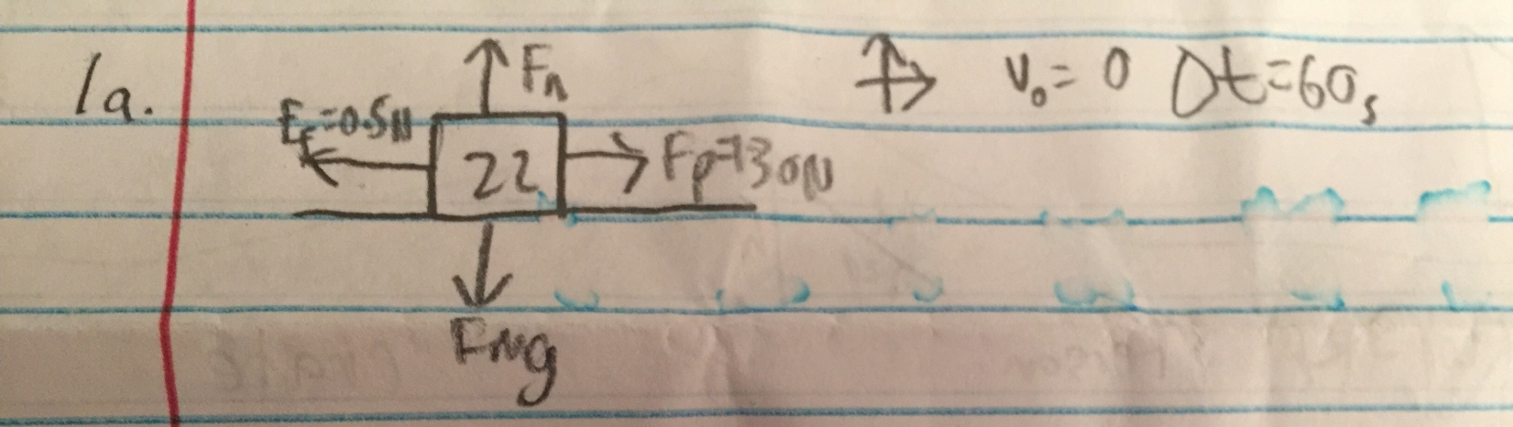

b) Find the impulse transferred to the block by the 130 N force.

I=Ft=130*60=7800Ns

c) Find the impulse transferred to the block by the frictional force.

I=Ft=.5(22)9.8(60)=6468Ns (107.8N)

d) Use the impulse-momentum theorem to find the final speed of the block.

I=mv’-mv_{o}
V’=(I-mv_{o})/m=((7800-6400)-0)/22=60.5m/s

e) How do you know that this final speed is correct? One way to check your answer is to solve the problem in another way and compare the results. Use Newton's second law to find the acceleration of the block. Use this acceleration in one of the "magic" formulas to find the speed after 60 seconds has elapsed. Does this equal your answer in part d?

a=F/m
v=v_{o}+at=0+F/m*t=(130-107.8)/22*60=60.5m/s

2. In a ride at King’s Island, a 450 kg bumper car moving at 4.5 m/s “rear ends” a 550 kg bumper car moving at 3.7 m/s in the same direction. (Assume the collision is elastic.)

a) Write the equation which relates the relative velocities of the two cars before and after the collision. Use “v” to indicate the final velocity of the 450 kg car and “V” to indicate final velocity of the 55 kg car.

m₁v₁+m₂v₂=m₁v+m₂V
v₁-v₂=V-v=0.8

b) Write the equation for conservation of momentum during this collision using the same symbols as in part (a) for the unknown velocities.

450*4.5+550*3.7= 450v+550V=4060kgm/s

c) Solve the relative velocity equation for the final velocity of the 450 kg car and substitute this velocity into the conservation of momentum equation. Solve the resulting equation for the final velocity of the 550 kg bumper car.

v=V-0.8
450(V-0.8)+550V=4060
V=4.42m/s

d) Substitute your answer from part (c) into the relative velocity equation and find the final velocity of the 450 kg car.

v=4.42-0.8=3.62m/s

e) These answers are supposed to describe a perfectly elastic collision. Calculate the total kinetic energy of the two bumper cars both before and after the collision. Are they equal?

Before: 0.5(450)4.5²+0.5(550)3.7²=8321J
After: 0.5(450)3.26²+0.5(550)4.42²=8321J
They are equal

f) The calculations of part (e) show that (1) the KE before the collision is >> the KE after, (2) KE before the collision is = the KE after, or (3) the KE before the collision is << the KE after. This means that mechanical energy is (1) gained, (2) unchanged, or (3) lost in an elastic collision.

g) If the collision lasts 1.0 seconds, what is the average force experienced by the 450 kg car during the collision?

F_{AVG}=∆p/t=(450*3.62-450-4.50)/1=-396N

h) The force experienced by the 550 kg car during the collision should be (1) much greater, (2) the same as, or (3) much smaller than the force experienced by the 450 kg car.
_________________________________________________________________________________________

3. In another ride at King’s Island, a 450 kg bumper car moving at 4.5 m/s “rear ends” a 550 kg bumper car moving at 3.7 m/s in the same direction and the two cars “stick together” after the collision.

a) Write the equation for conservation of momentum during this collision and find the velocity of either car after the collision.

m₁v₁+m₂v₂=(m₁+m₂)V
V=(450*4.5+550*3.7)/(450+550)=4.06m/s

b) This collision is said to be completely inelastic. Calculate the total kinetic energy of the two bumper cars before and after the collision.

Before: 0.5(450)4.5²+0.5(550)3.7²=8321J
After: 0.5(450+550)4.06²=8242J

c) The calculations of part (b) show that (1) the KE before the collision is > the KE after, (2) KE before the collision is = the KE after, or (3) the KE before the collision is < the KE after. This means that mechanical energy is (1) gained, (2) unchanged, or (3) lost in the collision.

d) If the collision lasts 1.0 seconds, what is the average force experienced by the 450 kg car during the collision?

F_{AVG}=∆p/t=(450*4.06-450-4.50)/1=-198N

e) The force experienced by the 550 kg car during the collision should be (1) much greater, (2) the same, or (3) much smaller than that experienced by the 450 kg car.

f) Compare the average force experienced by the 450 kg car in the elastic collision, #2(g), with that experienced in the completely inelastic collision, #3(d). Explain why your results are reasonable.

The collision in #2 was greater than the collision in #3. This makes sense because energy is lost in the inelastic collision.

